**Hand gesture based devices control**

**Aim:**

To operate real world devices with the help of hand movement and provide innovative facilities to its users.

**Description:**

There will be an IMU sensor and two-three digital input attached on the user's hand along with a microcontroller circuit. This will extract 3D coordinates from sensor values and determine the gestures, for each recognized gesture a character will be sent over Bluetooth.

The second microcontroller unit receives these values via Bluetooth and can perform one of the various applications, for example:

1. Android app control
2. Relay based device operation
3. Remote controlling devices (TV, Cranes, Toys, Machines, etc.)
4. Mouse cursor control

**Block Diagram**:

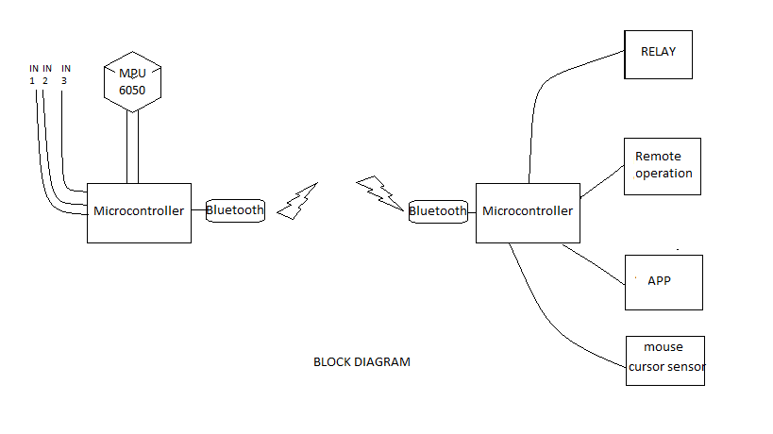

**Hardware:** Inertial Mass Unit(MPU-6050/ADXL345), Microcontroller(Arduino & mbed LPC11U24)(X2), Bluetooth Module(X2), Android phone, Touch Sensor(X2), Servo motor(X2), Stepper Motor(X1), Vibrator Motor(X4), Relays, Buttons, LEDs, etc.

**Software**: Linux Driver, Android App, Arduino IDE, mbed online compiler,

**Group Size** : 2 people.

**Group Members** : 1. Md. Asad Rehman

2. Jagadishwar Pampad